Poznamky z chapter 6

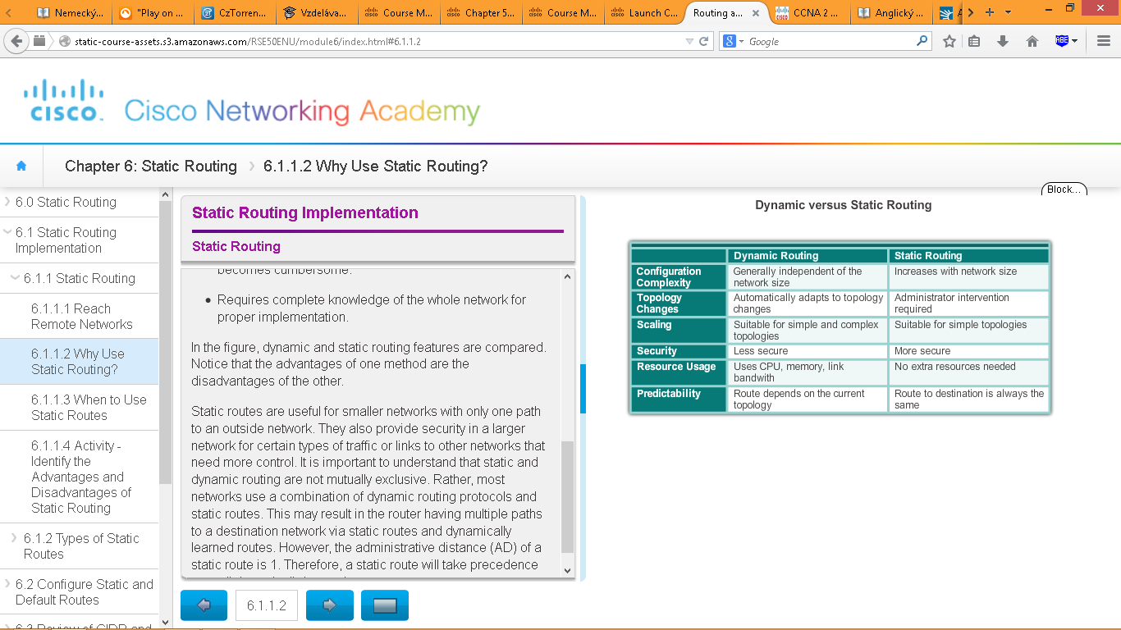

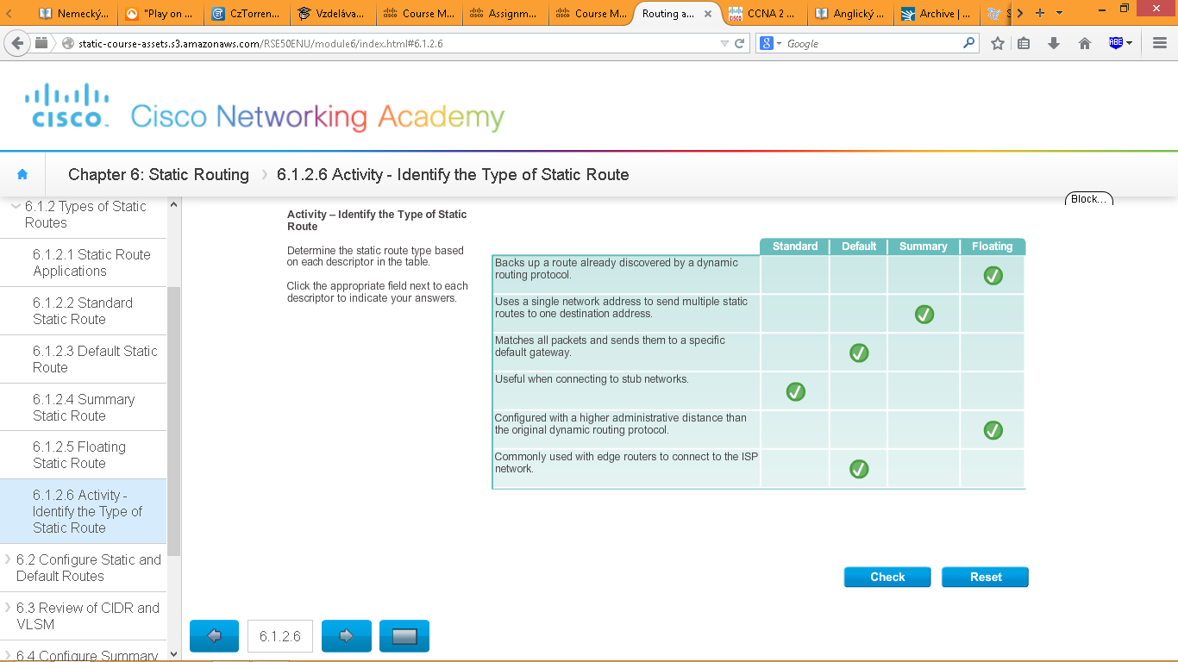

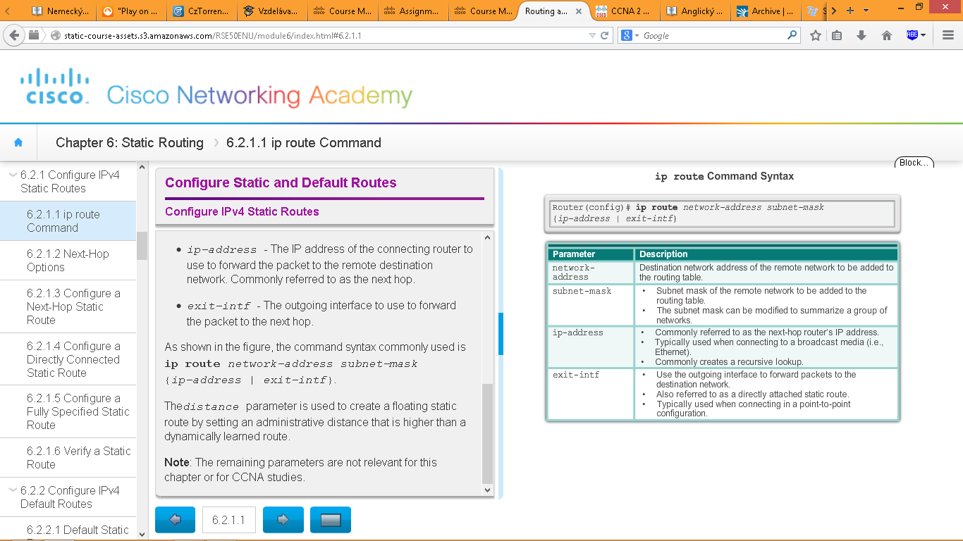Router(config)# **ip route** *network-address subnet-mask* { *ip-address* | *interface-type interface-number* [ *ip-address* ]} [ *distance* ] [ **name** *name* ] [ **permanent** ] [ **tag** *tag* ]

Distance = admin. vzdialenost/

nedoveryhodnost



Along with ping and traceroute, useful commands to verify static routes include:

show ip route

show ip route static

show ip route network

DEFAULT ROUTE

A default route is a static route that matches all packets. A default route is used when no other routes in the routing table match the destination IP address of the packet.

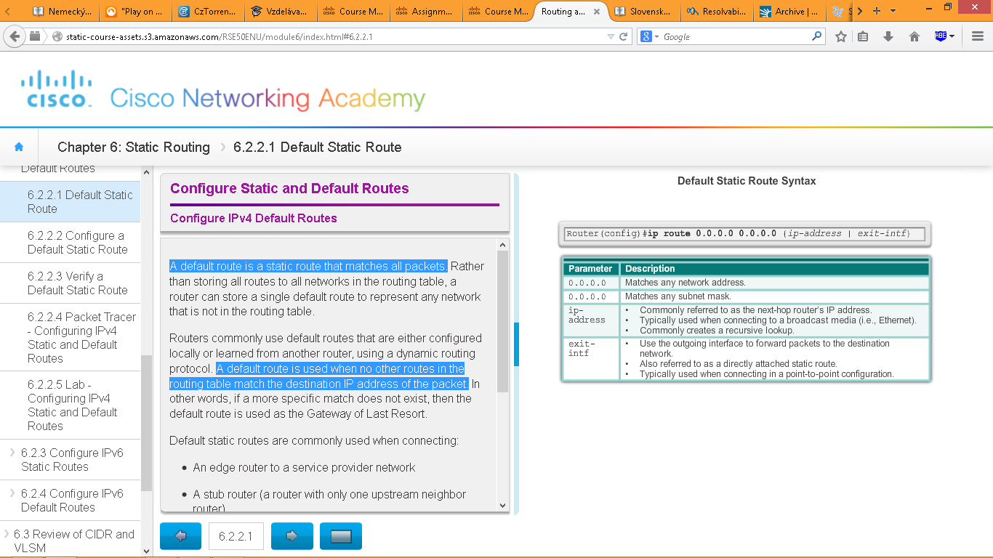

By default, static routes have an administrative distance of 1

Konfiguracia predvolenej (*default*) a záložnej(plávajúcej-*floating*) cesty

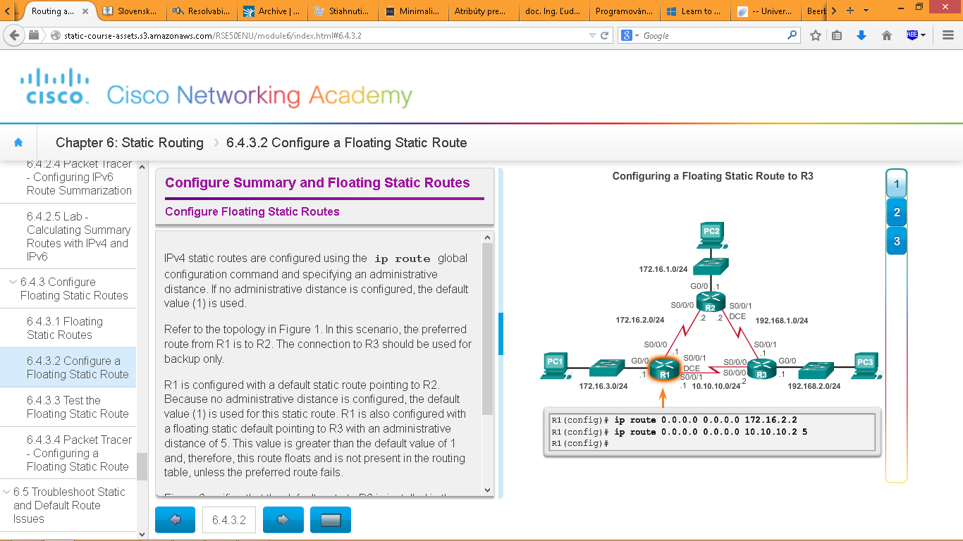

What would happen if R2 failed? To simulate this failure both serial interfaces of R2 are shut down

Common IOS troubleshooting commands include:

ping

traceroute

show ip route

show ip interface brief

show cdp neighbors detail

The incorrect route is removed and the correct route is then entered.

